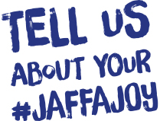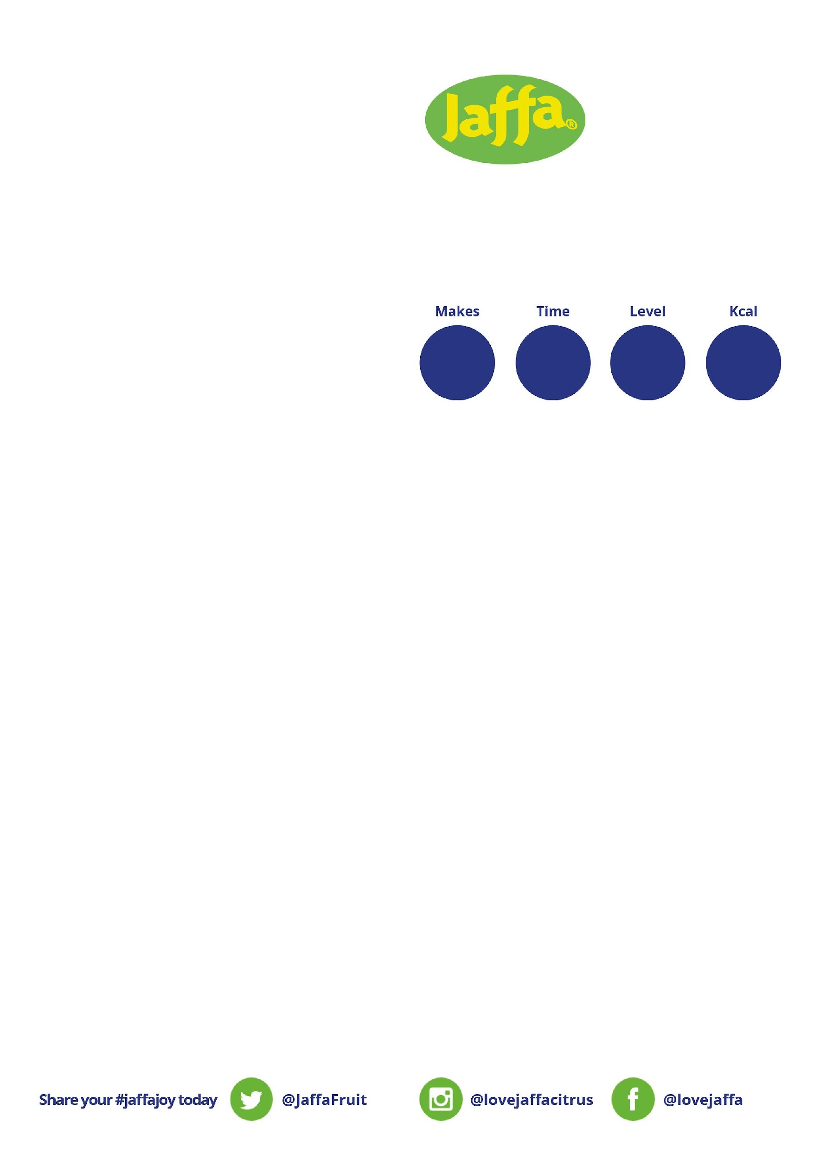

**90**

**24**

**Our step-by-step guide**

Step 1

Soak the Medjool Dates in hot water (use enough water to just cover the dates) for ten minutes.

Step 2

Once the Medjool Dates have soaked, place them in a blender and blitz to a paste, adding small splashes of their soaking water until you’re done. Then set aside.

Step 3

Stir together the Pecans, Jaffa Juicy Orange zest and spices until combined. Fold in the date paste, dried fruit and a squeeze of Jaffa Juicy Orange juice.

Step 4

Roll the mixture into balls (you can add a drizzle of maple syrup for a sweeter hit, if desired), adding more ground almonds if the mix is too sticky. Then chill for 20 minutes.

Step 5

Melt the white chocolate with coconut oil, then drizzle over each energy ball. Decorate with edible holly sprinkles.

Step 6

Enjoy!

**You will need**

|  |
| --- |
| 2 x Jaffa Juicy Oranges, zested and juiced |
| 1 x Cup of Pecans, grounded to flour |
| 1 x Cup of Medjool Dates, pitted |
| ½ x Cup Almonds, grounded |
| 1 x Large Handful of Dried Fruit |
| 1 x Pinch of Nutmeg |
| 1 x TSP Vanilla |
| 1 x TSP Ground Cinnamon |
| ¼ x TSP Ginger (or more, to taste) |
| *Optional: Maple Syrup if you like it sweeter* |
|  |
| **For Decorating:** |
| 100g x White Chocolate |
| 1 x TSP Coconut Oil |
| Edible Holly Sprinkles |

**JAFFA ORANGE CHRISTMAS PUDDING ENERGY BITES**

**per portion n**

**15**

**minutes**

**Simple**